

***CONTAINERS AND DOCKERS***

***Submitted by:***

***NAME: Tanishqua Tellakula***

***SAP ID: 500084269***

***Roll number :R120220007***

***Batch: B1(Hons)***

***Lab Exercise 9- Managing Namespaces in Kubernetes***

***Step 1: Understand Namespaces***

*Namespaces provide a mechanism for scoping resources in a cluster. Namespaces can be used to:*

* *Create environments for different applications or teams.*
* *Apply policies like resource quotas or network policies on a per-namespace basis.*
* *Separate operational environments (like development and production).*

***Step 2: List Existing Namespace:***

*To list all the namespaces in your Kubernetes cluster:*

|  |
| --- |
| ***kubectl get namespaces*** |

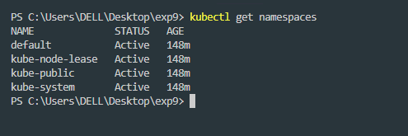

*You will typically see default namespaces like default, kube-system, and kube-public.*

***Step 3: Create a Namespace***

*You can create a namespace using a YAML file or directly with the kubectl command.*

*Using YAML File*

*Create a file named my-namespace.yaml with the following content:*

|  |
| --- |
| ***apiVersion: v1***  ***kind: Namespace***  ***metadata:***  ***name: my-namespace*** |

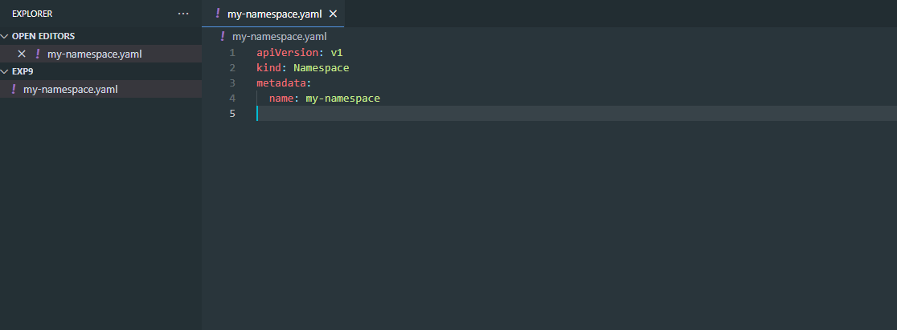

*Apply this YAML to create the namespace:*

|  |
| --- |
| ***kubectl apply -f my-namespace.yaml*** |



*Verify that the namespace is created:*

|  |
| --- |
| ***kubectl get namespaces*** |

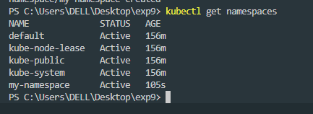

*You should see my-namespace listed in the output.*

***Step 4: Deploy Resources in a Namespace***

*Create resources such as Pods, Services, or Deployments within the new namespace.*

*Deploy a Pod in the Namespace*

*Create a YAML file named* ***nginx-pod.yaml*** *with the following content:*

|  |
| --- |
| ***apiVersion: v1***  ***kind: Pod***  ***metadata:***  ***name: nginx-pod***  ***namespace: my-namespace # Specify the namespace for the Pod.***  ***spec:***  ***containers:***  ***- name: nginx***  ***image: nginx:latest***  ***ports:***  ***- containerPort: 80*** |

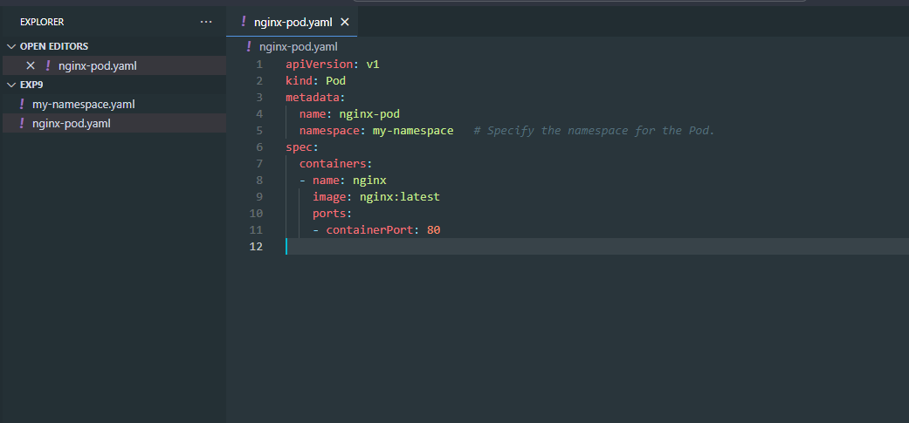

*Apply this YAML to create the Pod:*

|  |
| --- |
| ***kubectl apply -f nginx-pod.yaml*** |

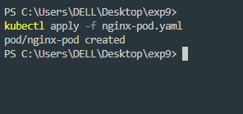

*Check the status of the Pod within the namespace:*

|  |
| --- |
| ***kubectl get pods -n my-namespace*** |

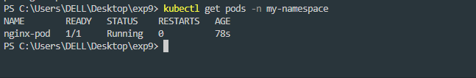

*To describe the Pod and see detailed information:*

|  |
| --- |
| ***kubectl describe pod nginx-pod -n my-namespace*** |

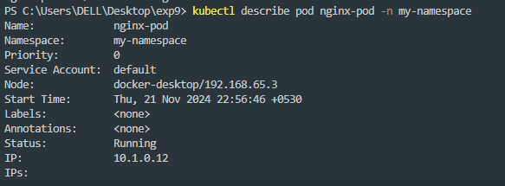

*Create a Service in the Namespace*

*Create a YAML file named nginx-service.yaml with the following content:*

|  |
| --- |
| ***apiVersion: v1***  ***kind: Service***  ***metadata:***  ***name: nginx-service***  ***namespace: my-namespace # Specify the namespace for the Service.***  ***spec:***  ***selector:***  ***app: nginx-pod***  ***ports:***  ***- protocol: TCP***  ***port: 80***  ***targetPort: 80***  ***type: ClusterIP*** |

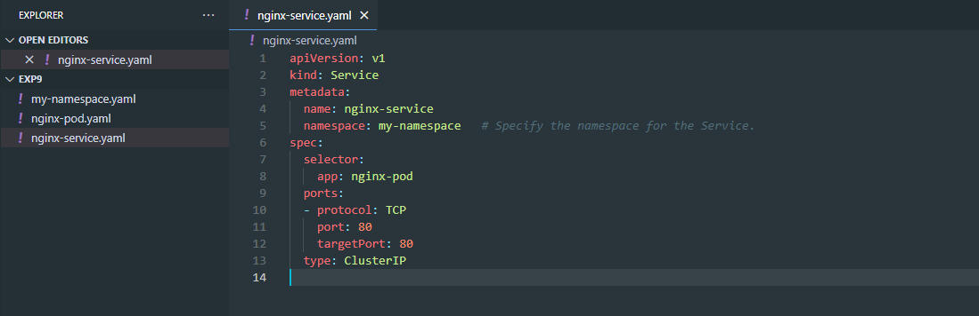

*Apply this YAML to create the Service:*

|  |
| --- |
| ***kubectl apply -f nginx-service.yaml*** |

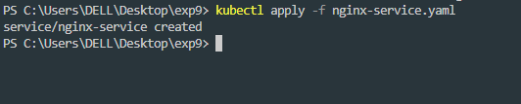

*Check the status of the Service within the namespace:*

|  |
| --- |
| ***kubectl get services -n my-namespace*** |

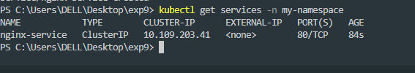

*To describe the Service and see detailed information:*

|  |
| --- |
| ***kubectl describe service nginx-service -n my-namespace*** |

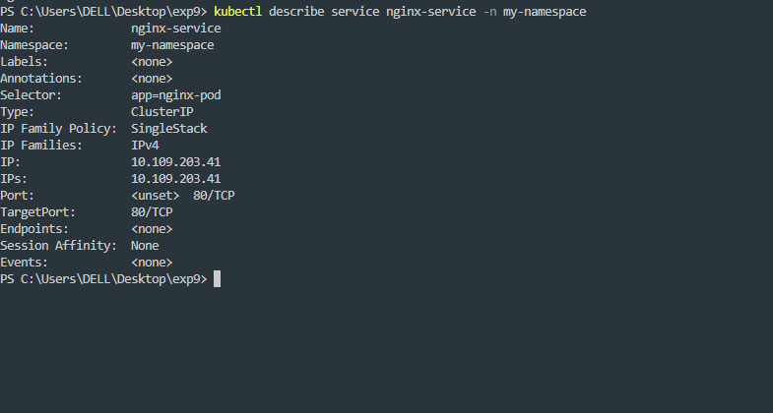

***Step 5: Switching Context Between Namespaces***

*When working with multiple namespaces, you can specify the namespace in kubectl commands or switch the default context.*

***Specify Namespace in Commands***

*You can specify the namespace directly in kubectl commands using the -n or --namespace flag:*

|  |
| --- |
| ***kubectl get pods -n my-namespace*** |

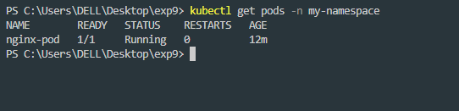

***Set Default Namespace for kubectl Commands***

*To avoid specifying the namespace every time, you can set the default namespace for the current context:*

|  |
| --- |
| ***kubectl config set-context --current --namespace=my-namespace*** |

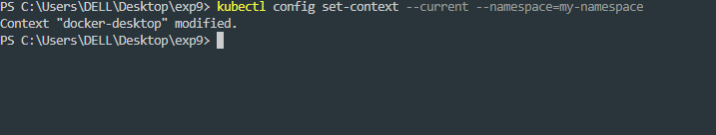

*Verify the current context’s namespace:*

|  |
| --- |
| ***kubectl config view --minify | grep namespace:*** |

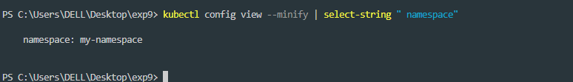

***Step 6: Clean Up Resources***

*To delete the resources and the namespace you created:*

|  |
| --- |
| ***kubectl delete -f nginx-pod.yaml***  ***kubectl delete -f nginx-service.yaml***  ***kubectl delete namespace my-namespace*** |

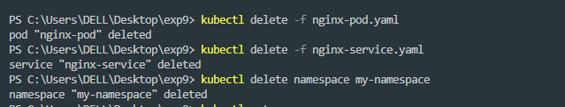

*Ensure that the namespace and all its resources are deleted:*

|  |
| --- |
| ***kubectl get namespaces*** |

